Homework 1

ECE 253

Minxuan Wang A53077257

October 10, 2015

* **Problem 1. MATLAB basics**

1. 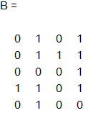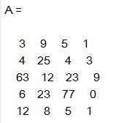
2. 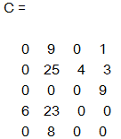
3. 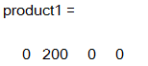
4. 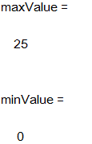

maxValue index: (2,2)

minValue index: (1,1), (2,1), (3,1), (5,1), (3,2), (1,3), (3,3), (4,3), (5,3), (4,4), (5,4)

* 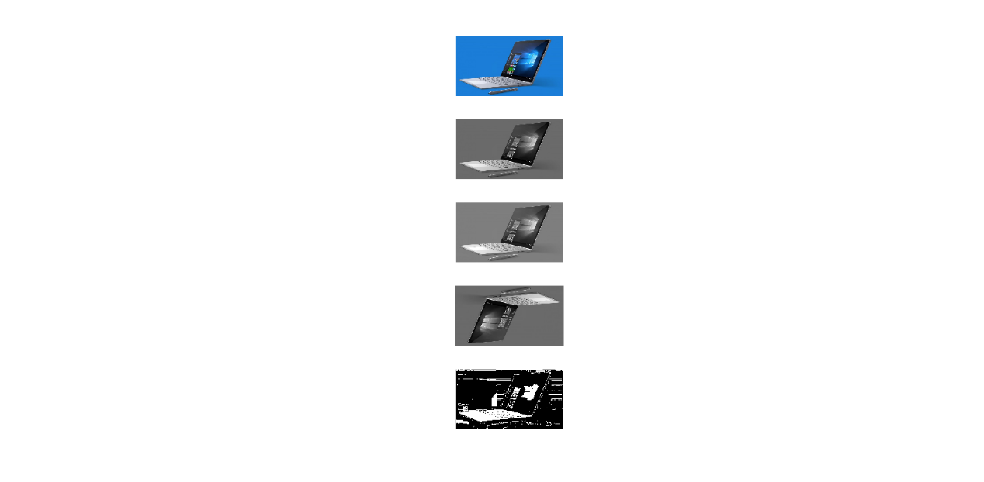**Problem 2. Simple image manipulation**
* **Problem 3. Keyboard Conundrum**

1. When k = 0:

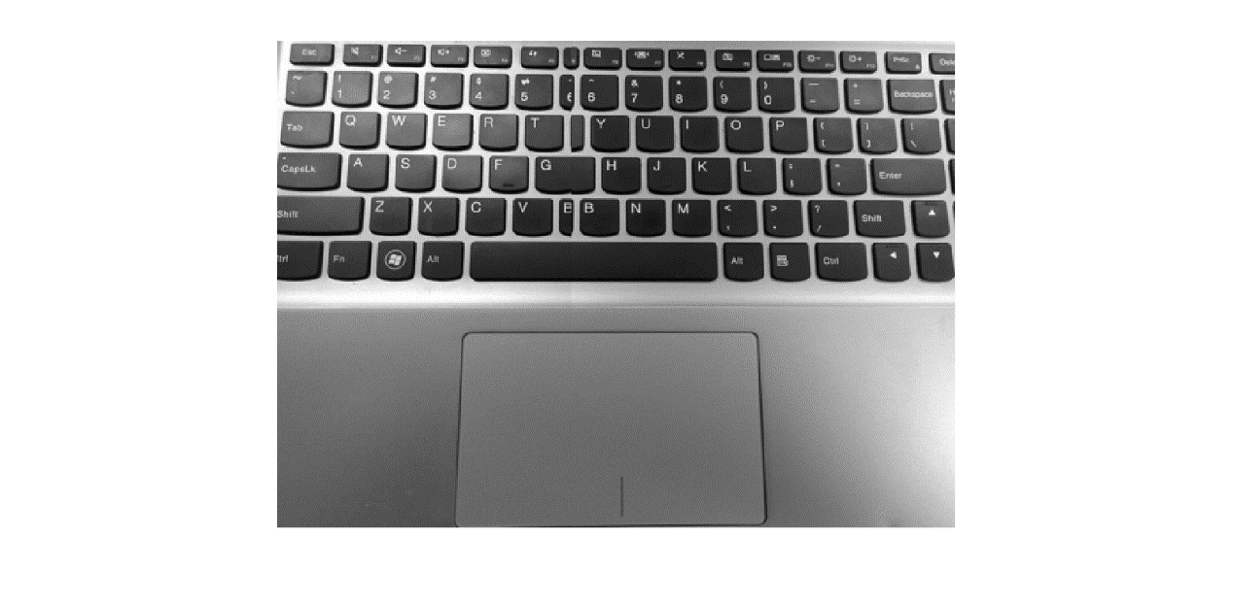

1. 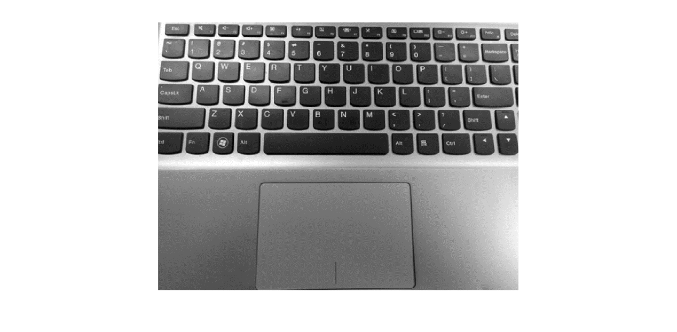When k = 15:

k = 15 is the best k I got.

* Appendix

%% Problem 1: MATLAB basics

% i: Input A and B

A = [3 9 5 1; 4 25 4 3; 63 12 23 9; 6 23 77 0; 12 8 5 1];

B = [0 1 0 1; 0 1 1 1; 0 0 0 1; 1 1 0 1; 0 1 0 0];

% ii: Point-wise multiply A with B and set it to C.

C = A.*B;

% iii: Calculate the inner product of 2nd row and 5th row of C.

product1 = C(2, :) .* C(5, :);

% iv: Find the minimum and maximum values and their corresponding row and column indices in Matrix C

maxValue = max(C(:));

[rowIndex_max, colIndex_max] = find(C == maxValue);

minValue = min(C(:));

[rowIndex_min, colIndex_min] = find(C == minValue);

%% Problem 2: Simple image manipulation

% i: Download any color image from the Internet with a spatial resolution of no more than (720 X 480). Read this image into MATLAB. Call this image A.

A = imread('Surface-Book.jpg');

% ii: Transform the color image to grey-scale. Verify the values are between 0 and 255. If not, please normalize your image from 0 to 255. Call this image B.

B = rgb2gray(A);

% iii: Add 20 to each value of image B. Set all pixel values greater than 255 to 255. Call this image C

C = imadd(B, 20);

% iv: Flip image B along both the horizontal and vertical axis. Call this image D.

D1 = flip(B, 2); % horizontal

D = flip(D1, 1); % vertical

% v: Calculate the median of all values in image B. Next, threshold image B by the median value

% you just calculated i.e. set all values greater than median to 1 and set all values less than or

% equal to the median to 0. Name this binary image E.

medianB = median(B(:));

E = zeros(size(B,1), size(B,2));

for x = 1:size(B, 2)

for y = 1:size(B,1)

if B(y, x) > medianB

E(y,x) = 1;

else

E(y,x) = 0;

end

end

end

figure(1)

subplot(5, 1, 1)

imshow(A)

subplot(5, 1, 2)

imshow(B)

subplot(5, 1, 3)

imshow(C)

subplot(5, 1, 4)

imshow(D)

subplot(5, 1, 5)

imshow(E)

%% Problem 3

img = merge('D:\ucsd\ece253\laptop_left.png', 'D:\ucsd\ece253\laptop_right.png', 0);

figure(1)

imshow(img);

img = merge('D:\ucsd\ece253\laptop_left.png', 'D:\ucsd\ece253\laptop_right.png', 15);

figure(2)

imshow(img);

function [ img ] = merge( file1, file2, ncol )

left = imread(file1);

right = imread(file2);

[a1, b1, c1] = size(left);

[a2, b2, c2] = size(right);

img(1:a1, 1:b1) = left(1:a1, 1:b1);

img(1:a2, b1+1:b1+b2-ncol) = right(1:a2, 1+ncol:b2);

end